Terraform task -2

Task is to create 2 EC2 instances in 2 different regions, but when I tried due to service quota limit restriction on vCPU, ec2 instance creation failed

So I created 1 ec2 with 1vCPU in 2 different regions

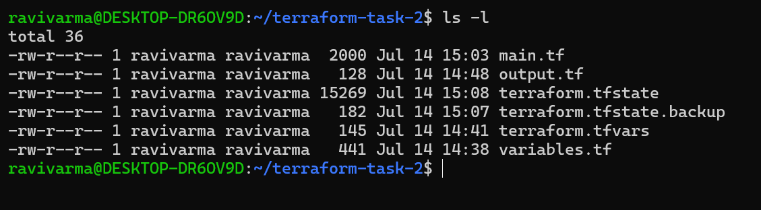

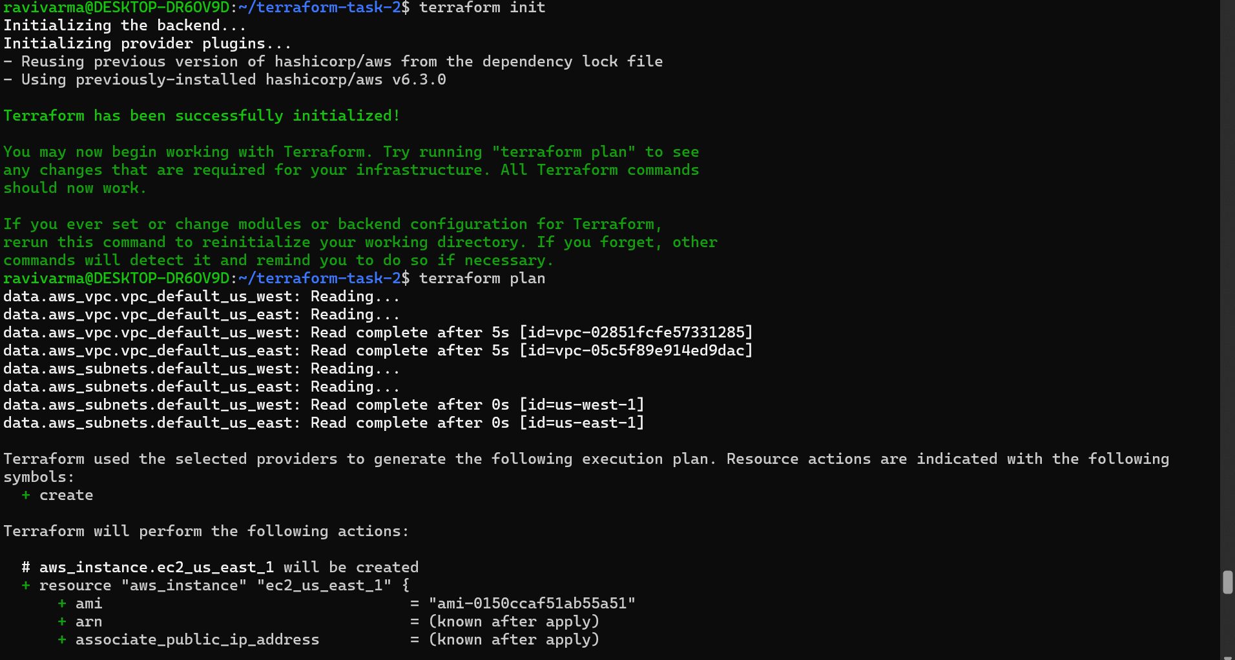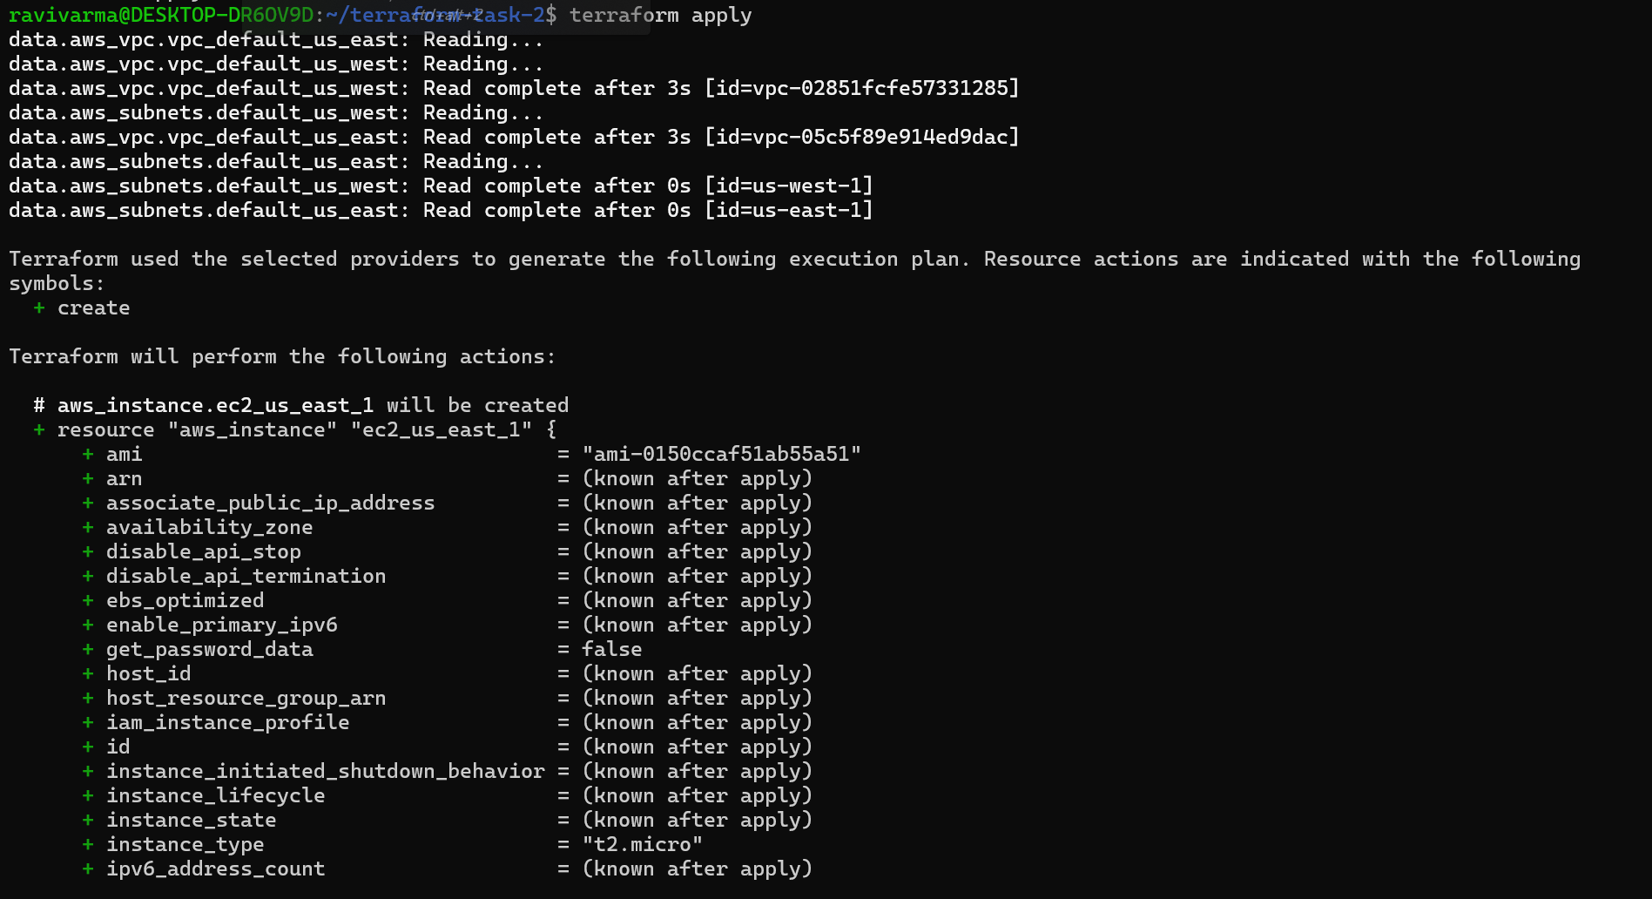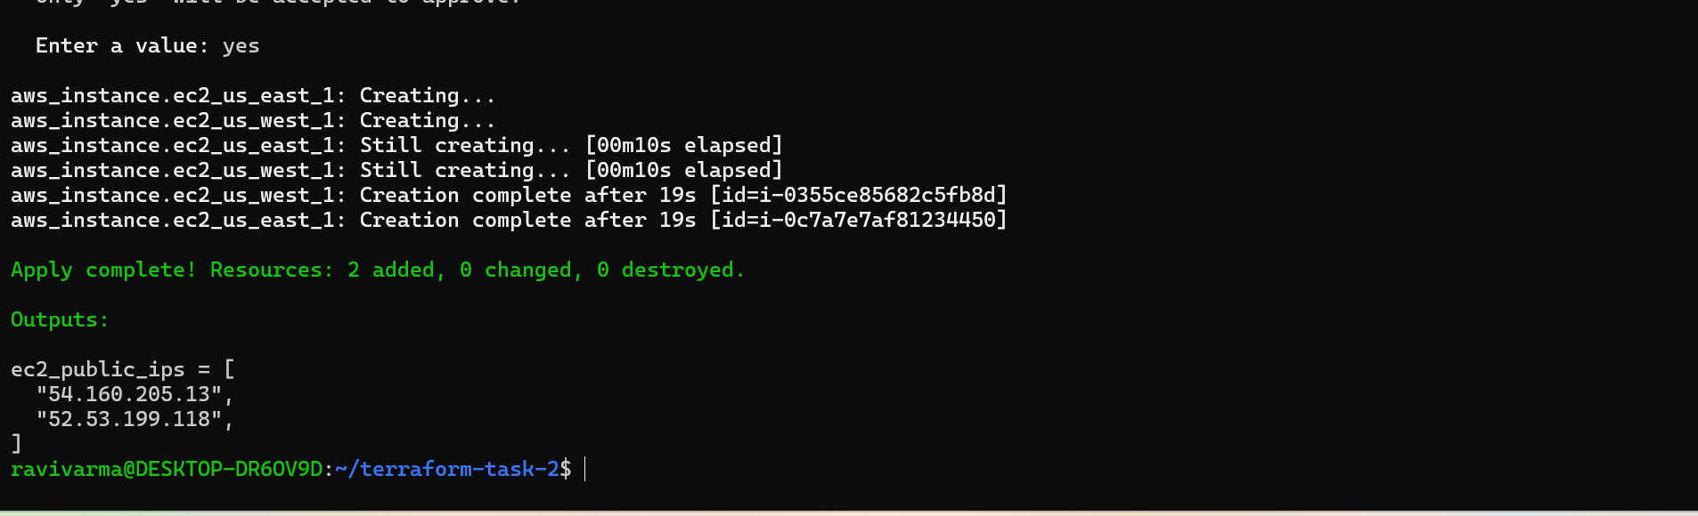

Nginx installed on the instances.

